Michigan State University
Model United Nations
Session XXIII
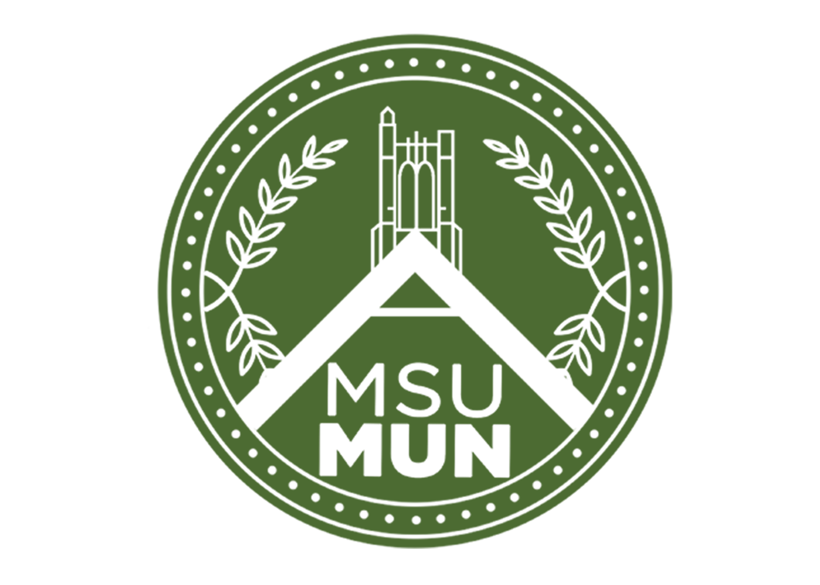
Introduction for First-Time Junior Staff

What is MSUMUN?
Michigan State University Model United Nations (MSUMUN) is a 501(c)(3) non-profit that is completely run by MSU students. As an organization, MSUMUN hosts annual Model UN conferences at the middle and high school levels. Model United Nations is an interactive debate style that puts students in the shoes of nations and people in the past, present, and future to solve world issues and rewrite history. As a member of MSUMUN, you would create and run these scenarios for students by preparing research for them, moderating debate, and sometimes acting out scenarios. We have ample leadership roles to fill every year; joining as a junior staff is the first step to filling one. Additionally, MSUMUN has social events throughout the year for you to meet and get to know our over 100 members. For more info, please see our website here: msumun.org

What are Junior Staff?
Junior Staffers are the largest section of staff in MSU Model United Nations and fill a wide range of positions. Within the category of Junior Staff, applicants can serve as Committee Staff and Crisis Staff. Within each of these areas Junior Staff will work with and be guided by Senior Staff who are veteran staff members. No prior knowledge or experience with Model UN is necessary for Junior Staff! Every applicant will be placed.

* While this is called an application, think of it more as a placement interest form. *

The time commitment for Junior Staff is difficult to quantify, but Junior Staff can usually expect weekly meetings arranged by their Senior Staff in addition to the mandatory calendar commitments assigned by MSUMUN. The time commitment is greatest in the months of February and March near conference times. Below is a calendar with dates specific to Junior Staff. The calendar and expectations will be discussed more thoroughly at the First All Staff Meeting on September 28nd, 2023.
MSUMUN XXIII Junior Staff Calendar
Please note: Dates are subject to change and all times are tentative

September:
Tuesday, Sept 5th, 7pm: MSUMUN XXII Committee Fair @ Case Hall
Junior Staff Applications open
Monday, Sept 18th, 11:59pm: Junior Staff Applications due
Sunday, Sept 24th, all day: Junior Staff Hiring
Thursday, Sept 28th, 7pm: First All-Staff Meeting

October:
Thursday, Oct 26th, 7pm: Second All-Staff Meeting

November: Friday, Nov 3rd, 11:59 pm: Background Guide rough drafts due Sunday, Nov 5th, 12:00 pm: All-Staff Simulation #1

December:
Sunday, Dec 3rd, 12:00 pm: All-Staff Simulation #2
Sunday, Dec 10th, 11:59 pm: Background Guide final drafts due

January:
Thursday, Jan 11th, 7pm: Third All-Staff Meeting
Sunday, Jan 14th, 12pm: All-Staff Simulation #3
Tuesday, Jan 30th, 7pm: RCMUN Logistics Meeting

February:
Saturday, Feb 3rd, all day: RCMUN Conference
Thursday, Feb 15th, 7pm: Fourth All-Staff Meeting
Sunday, Feb 18th, 12pm: All-Staff Simulation #4

March:
Tuesday, Mar 12th, time TBD: MSUMUN Logistics Meeting
Friday-Sunday, Mar 15th-17th, all day: MSUMUN Conference

Junior Staff Placement Form

No prior MUN experience needed to apply! Applications are used to determine committee preference and ability, and all applicants will be placed with a committee.

Submit your completed application to cos@msumun.org. The file should be named “Firstname_Lastname” and saved as a PDF. Please write your answers in a different text color so that it is easier for staff to read.

Applications are due on Monday, September 18th at 11:59pm. Interviews will be held on Sunday, September 24th, between the hours of 10am and 4:30pm. Your interview time will be communicated via an email from Jane Swartz at cos@msumun.org on or before Friday, September 22nd.

Your interview will be roughly 10 minutes long. A full document detailing the interview process will be sent to you along with your interview time slot.

If you have any questions or concerns, please direct them to Jane at cos@msumun.org.

General Information:
Please answer the following questions:
Full Name:
Pronouns (if you wish to disclose):
E-mail:
Major(s):
Phone Number: |  |  | Expected Graduation:
Month Year
College(s):

Returning Staff (Y/N): |  | T-Shirt Size:

Were you recruited by a staff member? (Y/N): ___________

If yes, who? __________________________

MSUMUN General Questions

How do you spend your free time (hobbies, interests, etc.)?
- What are you most excited about for MSUMUN XXIII?

- What will you contribute to MSUMUN, and what do you hope to get out of this experience?

- Do you have any previous Model United Nations experience? If so, please list and explain.

- What other time commitments do you have this year? You may include a schedule if available.

MSUMUN XXIII Committees and Crises

General Assemblies:
International Telecommunications Union (ITU)
World Health Organization (WHO)
International Monetary Fund (IMF): The Asian Financial Crisis, 1997

Specialized Committees:
In Hot Water: The Great Lakes Compact
A Slippery Slope: Nepal’s Troubling Tourist Industry
Look What You Made Her Do: The Sale of Taylor Swift’s Masters
Triangle Shirtwaist Factory Aftermath

Crisis Committees:
Klondike Gold Rush of 1896
One Seamless People: The Mali Federation, 1959
TikTok: Board of Directors
A Spark of Hope Behind the Iron Curtain: The Hungarian Revolution of 1956
War of the Triple Alliance: Paraguay in Peril
Ad Hoc: Committee of the Secretary-General

Committee and Crisis Questions

- If you were recruited by a senior staffer, who were they and what is their committee?

- MSUMUN has run committees and crises as diverse as an ancient Egyptian Pharaoh’s council to a futuristic Mars colony; no place or time is beyond our reach. With this in mind, what regional, social, cultural, historical or other specialized areas are you especially passionate or knowledgeable about?

- Please rank in order from highest to lowest your preference of all the committees at MSUMUN XXIII, and explain your ranking for your top five committees. Additionally, please indicate on a scale of 1 and 10 your enthusiasm for each committee. (Integers only; no decimals).

Example: 1. Look What You Made Her Do: The Sale of Taylor Swift’s Masters – 10
2. International Monetary Fund (IMF): The Asian Financial Crisis, 1997 – 8
3. TikTok: Board of Directors – 7

- International Telecommunications Union (ITU)
- World Health Organization (WHO)
- International Monetary Fund (IMF): The Asian Financial Crisis, 1997
- In Hot Water: The Great Lakes Compact
- A Slippery Slope: Nepal’s Troubling Tourist Industry
- Look What You Made Her Do: The Sale of Taylor Swift’s Masters
- Triangle Shirtwaist Factory Aftermath
- Klondike Gold Rush of 1896
- One Seamless People: The Mali Federation, 1959
- TikTok: Board of Directors
- A Spark of Hope Behind the Iron Curtain: The Hungarian Revolution of 1956
- War of the Triple Alliance: Paraguay in Peril
- Ad Hoc: Committee of the Secretary-General

Position Descriptions

Below is a description of each Junior Staff position and the committees MSUMUN will be running at Session XXIII. To learn more about each committee, follow the links below.

Committee Staff:
General Assembly Assistant Chair: Directly assists the Chair in running the committee in terms of parliamentary procedure, research topics, and writing background guides.

Specialized Assistant Chair: Directly assists the Chair in running the committee in terms of parliamentary procedure, research topics, special committee structure, and the background guide.

Assistant Crisis Chair: Directly assists the Chair in running the committee in terms of parliamentary procedure as well as research topics and writing background guides.

Assistant Crisis Director: Support the Crisis Director with writing crisis drops, press releases, strategic acting, assistance in writing background guides, and other crisis development.

MSUMUN Position Questions

- Please rank in order your preferred positions from highest to lowest. The descriptions for each position can be found on page three.

- Assistant GA Chair
- Assistant Specialized Chair
- Assistant Crisis Director
- Assistant Crisis Chair

MSUMUN Wrap-Up and Scheduling Questions

- Is there anything else you would like Senior Staff to know about you?

- What is your availability on Sunday, September 24th, 2023?

- If you celebrate Yom Kippur, would you prefer an earlier interview time on Sunday?

